Secret Cyber Investigation Agency

DATE – Saturday, April 13, 2013

Software Design Specification

Version 2.0

Saurav Majumder – 10BCE0274

Saketh P – 10BCE0495

Naga Malleswara Rao – 10BCE0114

**Revision History:**

|  |  |  |  |
| --- | --- | --- | --- |
| **Name** | **Date** | **Reason For Changes** | **Version** |
| Agency | 14/2/2013 | User requirement not matching system requirement. | 1.0 |
| Agency | 24/2/2013 | Use case change | 1.1 |
| Agency | 4/4/2013 | More detailed Design | 2.0 |

**Constraints-**

Priority is given to confirmed cases rather than the suspicious ones and also the magnitude of the roll is measured (TS job) as in bank or credit card theft is given a higher priority than a hack of a twitter account. The tracking supervisors (TS) must make sure that their respective trackers are tracking/following the correct module and not falling out of their allotted track.

The online server is the Administrator of the project, and it updates the firewall for sites based on their issue of permission and the security that is already available on the site.

The people who are taking care of maintaining the Database in the tracking agency are constantly doing so as to avoid stagnation of data.

Not more than 2 cases are handled by a particular tracker at a point of time.

Definitions, Abbreviations and Acronyms:

|  |  |
| --- | --- |
| **Abbreviation** | **Definition or designation** |
| SCIA | Secret Cyber investigation Agency |
| TS | Tracking Supervisors |
| ADMIN | Administrator |
| WBS | Work Breakdown Structure |
| TA | Tracking Agency |
| OlS | Online Server |

OBJECTIVE

The following project aims to develop a scene software for a certain secret cyber agency. In this, we develop a web based application which interactively maps the design and functioning of an agency which monitors the activities in a city to keep the criminal cyber activities like phishing and username/password theft under control with a successful crime solving rate. Secret tracking officers are used to solve complex cases where an interactive system is maintained to ensure secure transfer of information between agency and its agents. This type of software has a wide scope in the future so that the government with the help of ministry and the agency can keep track and live with a crime free environment. Here, all the programming work is done with PHP and Xamp as the main detail orients and then developed perfectly for further description.

SCOPE

This software has a very wide scope in future as with time technology is on the up rise and an efficient, fast and secure mode of communication needs to be provided so that the Government with the help of the Ministry of Defence and Agency can provide a crime free environment. The software has been designed in a way that all organizations which use a security tool can easily accommodate this in their system environment. They can hence deploy this software in their systems and achieve improved security.

Architecture Modelling-

**System Structuring:**

This project is a typical Web based application module, and thus needs to be implemented by a **client-server** architecture, but since there are many hierarchies in the project, it also follows client-server architecture at different levels of the project. Online Server -> Tracking Supervisor -> Tracker.

Architecture Diagram-

Data Dictionary

Security System

Access to online Server

CYBER INVESTIGATION AGENCY

Encryption Module

Tracker’s and Hacker’s Database

Agency Work Space

**Control Models:**

Our project is driven by an online hierarchy that controls the TS which eventually controls the trackers. So, we can try to implement by using a top-down **CALL-RETURN** model. Here,we have to supply the input and we get the necessary output as specified in the user requirements(functionalities) in chapter 8.1 of the project.

Otherwise, we try to implement all the modules in Behavioral approach that is suitable for use as there is a small database and less collection with more implementation. It mainly consists of the data flow diagram that shows the complete flow of the project. We also choose the **BEHAVIORAL** Model because of the only major fact that it does not have a highly relational database and is very easy to communicate on different levels and entities of the project.

*Architectural Style (Modularity):*

We have defined set of modules that explicitly perform certain functions and activities, the entire project has been designed in such a way that it each module has a specific functionality based on the input to each and every module.

Input- Trackers need to fill in details like:

tracker_id

tracker_name

tracker_category

tracker_grade

Output- Auto generated messages, alerts for users. Case progress and status reports of each case. All received information from the agency which can help the tracker to track down hackers.

Description- The information gathered by the tracker is uploaded after encryption. Navigation and resource assistance from the agency.

Action- The trackers are assigned cases based on the agent grade. The trackers are recruited to sniff out hackers who have breached security of shopping forums and firewalls of home users.

Precondition- Trackers are given specific details for every case and all sorts of assistance to prevent cybercrime.

Post condition- Alert messages from the tracking agency and cases from the agency for their next target.

**Detailed Design Structure-**

Since, this project can be deployed into a Real Time System or at least expected to be in the near future, it can be considered that it can be used to an appropriate level.

Class Diagram

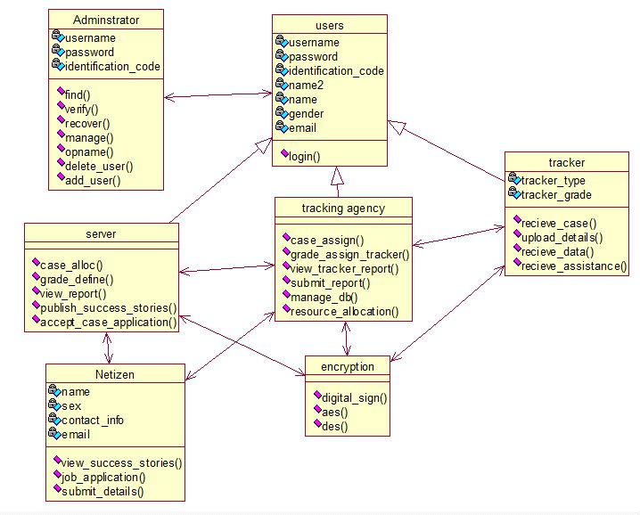

Heavy amount of abstraction is done because data is fetched in large quantities and is helpful for the project even after complete product is developed in the program.

Sequence Diagrams

1. Registration Sequence

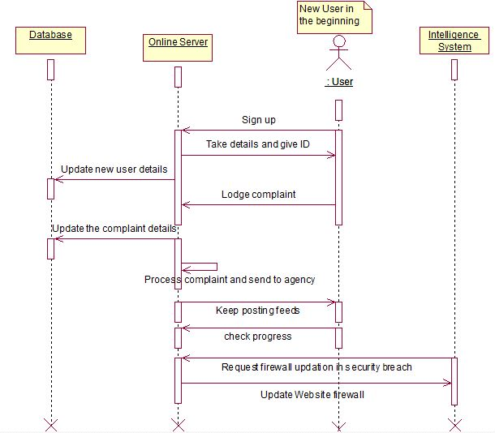

1. Work allocation and split up-

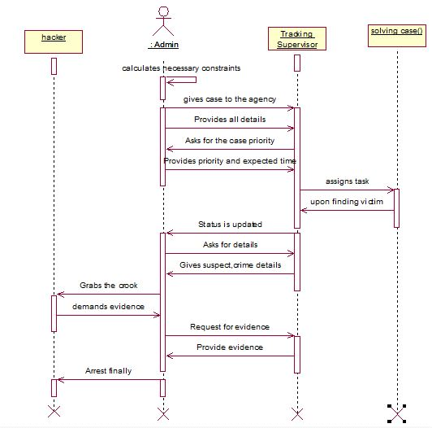

1. Case solution and finish sequence-

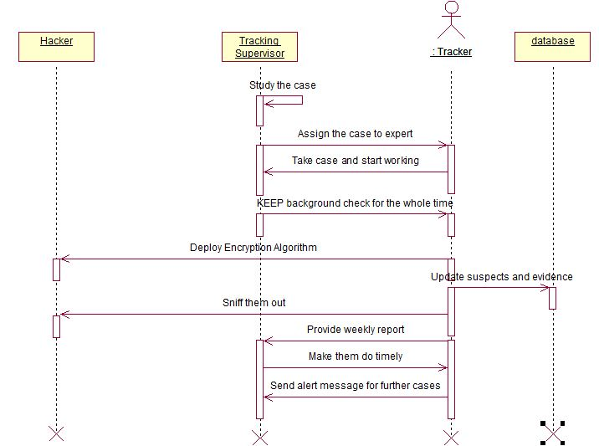

If we make a complete study on the basis of further refinement, once done the module can be kept aside and another module can be added on it but that module can’t be altered further as we follow the standard incremental approach level.

Activity Diagram

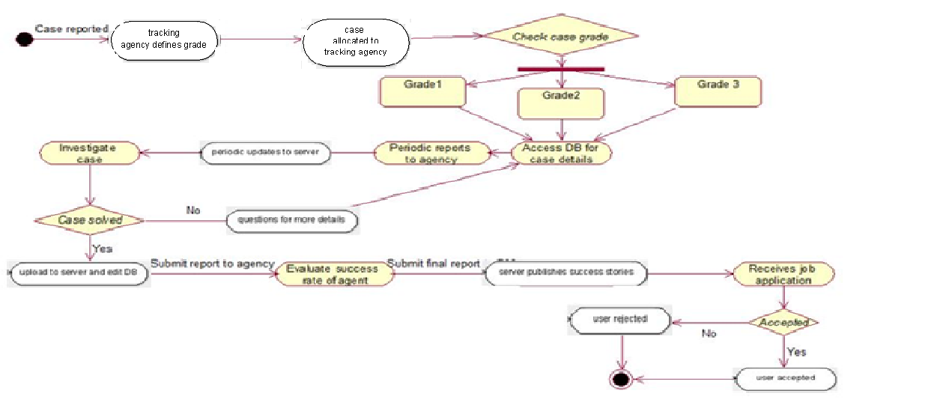

Collaboration Diagrams-

Registration:

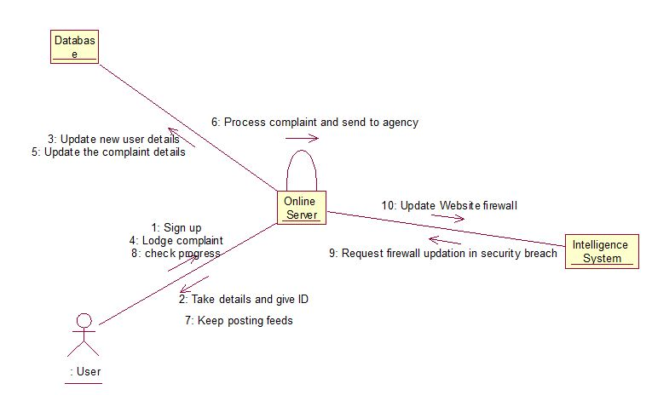

**Work allocation**

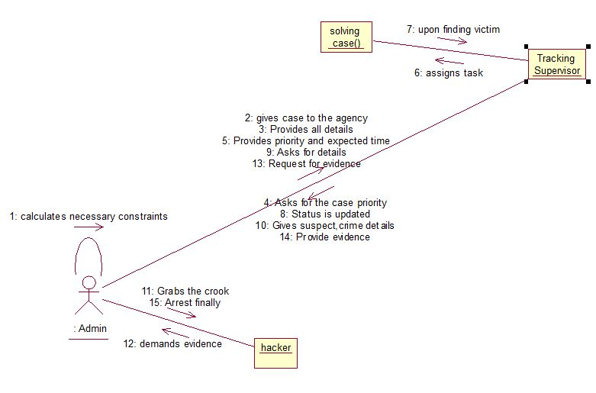

Solution of the case:

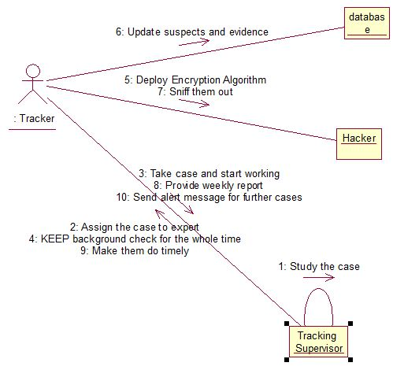

State Chart Diagram

1. 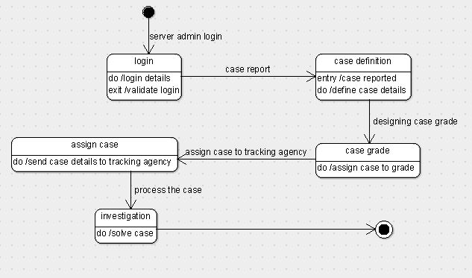State Transitions for Online Server:
2. State Transitions for Tracking Agency

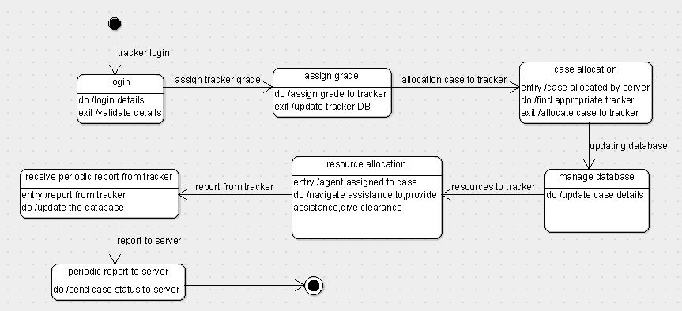

c) State Transitions for Tracker:

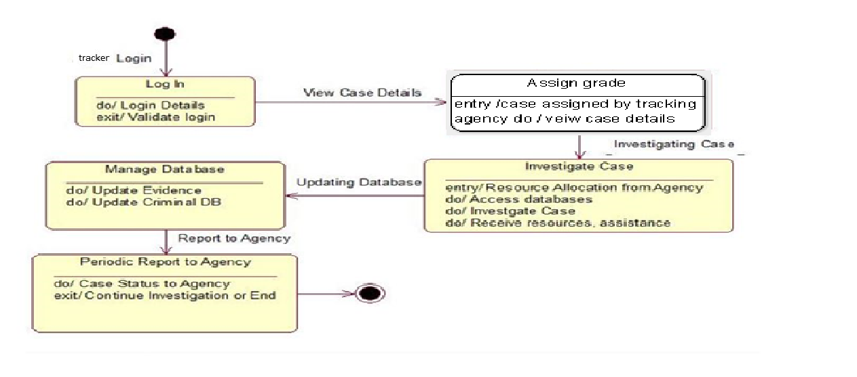

d) State Transitions for User

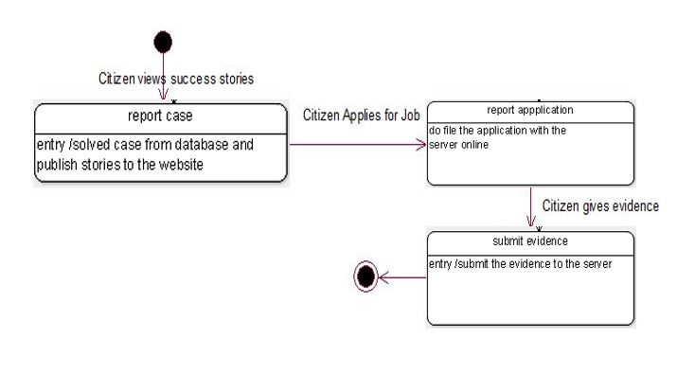

Data Design

* Data Dictionary
* Here no data structures are used as we don’t need to insert huge amounts of data, but we only have a small data dictionary for our convenience instead of an ER detailed diagram. Since this project is one to be implemented and a virtual approach to how things are done, we don’t have enough details to make an ER diagram of its entities, although a Data Dictionary can be perfectly drawn based the characteristics the modules have.

|  |  |  |  |
| --- | --- | --- | --- |
| **Sno./Entities** | **Tracker details** | **Case/Hacker Details** | **Customer Details** |
| **1.** | Tracker_name | Cyber crime record | Customer_name |
| **2.** | Tracker_id | Case grade | Customer_no. |
| **3.** | Success_rate | Case_id | Customer_email |
| **4.** | Tracker_category | Case_status | Customer_id |
| **5.** | grade | Suspect_namee | Customer_status |
| **6.** | Tracker_status | Track_record | --------------- |

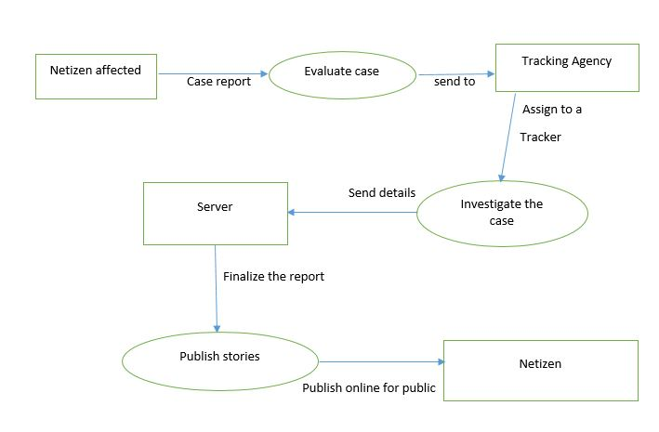Data Flow Diagrams

1. Case Definition by OS and Allocation by Agency
2. Case updating by tracker and user involvement:

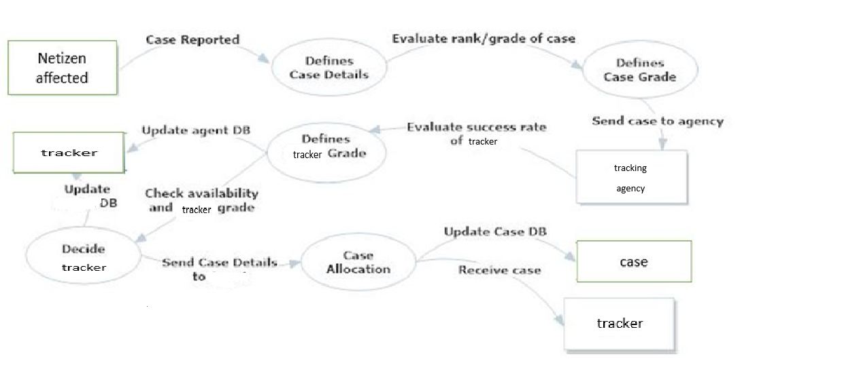

# Detailed Module Description

* Login with registration- A new user needs to register. The user comes and registers into the sign up. This entity is added into the database. Then the user needs to login with the username and password. If the user inputs an invalid username or password then and error message is displayed –“INVALID USERNAME OR PASSWORD”.
* Case Assignment (Tracking Agency)- Agent is assigned the case according to i) Case Grade ii) Availability A few parameters are kept in mind while assigning a case to any agent. The case grade is taken into consideration and mapped to the appropriate agent rank. If a match is found then availability is checked, case assignment assures that no agent is assigned more than two cases at a time. This ensures that no agent is overworked or under immense pressure, so that he can give optimum output.
* Case Viewing:

The status of the case can be viewed by anyone who is a user and has an option to express his views on the progress by making complaints which help the Agency to comprehensively rectify their faults or any little amount of functional errors.

* User Interface Design
* Online Server Case Assign

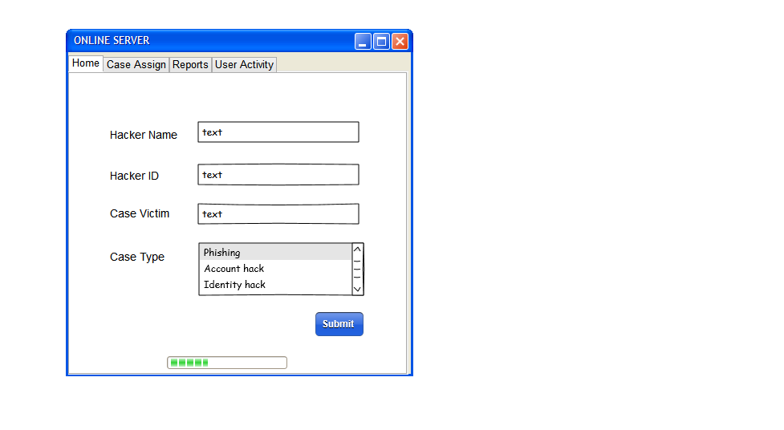

* OLS report

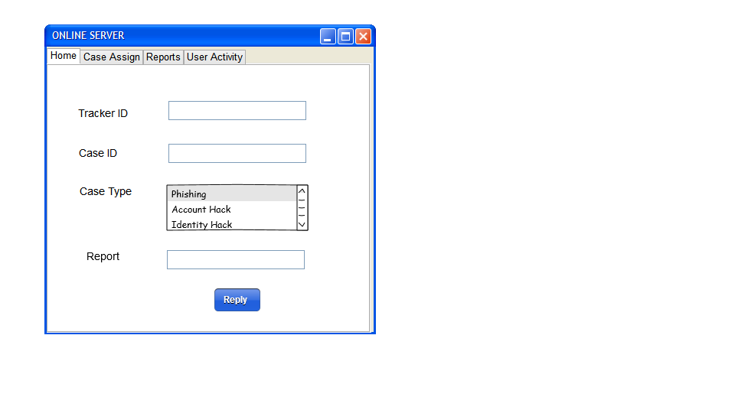

* Online Server-User Activity

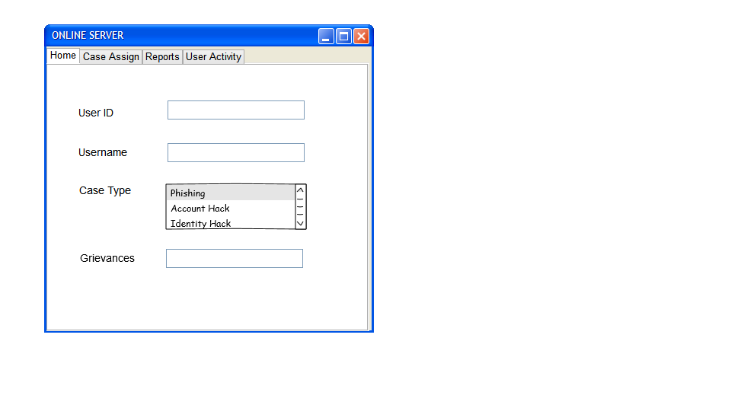 Online server – home

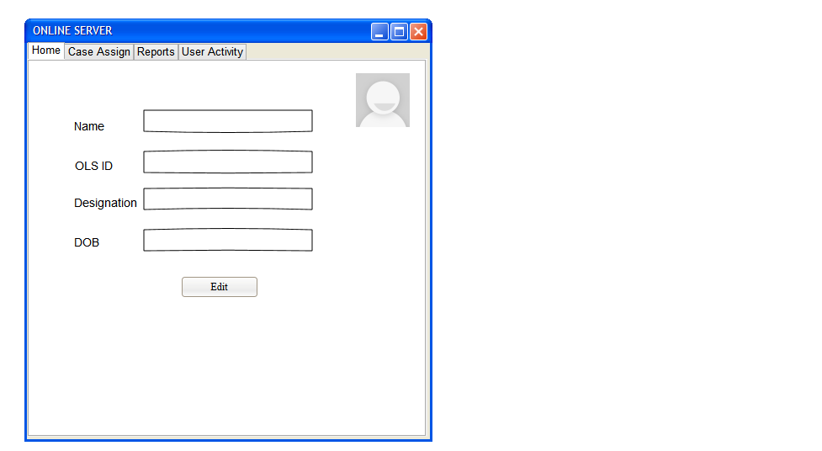

* Tracker Case Assign

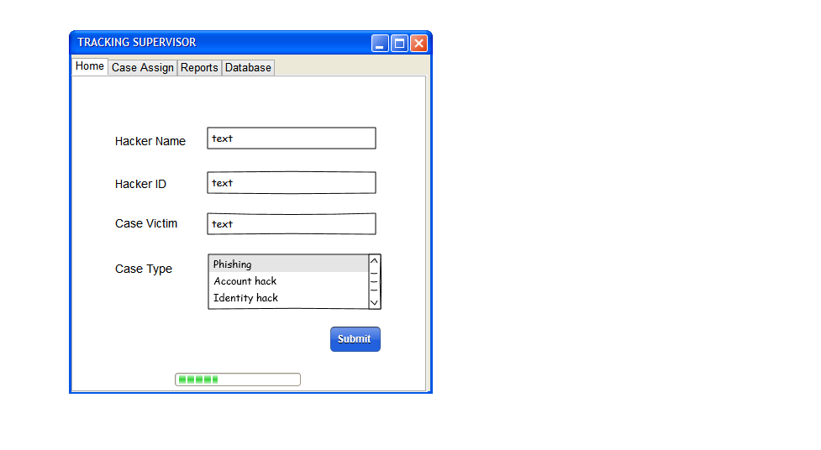

* Tracker Case details

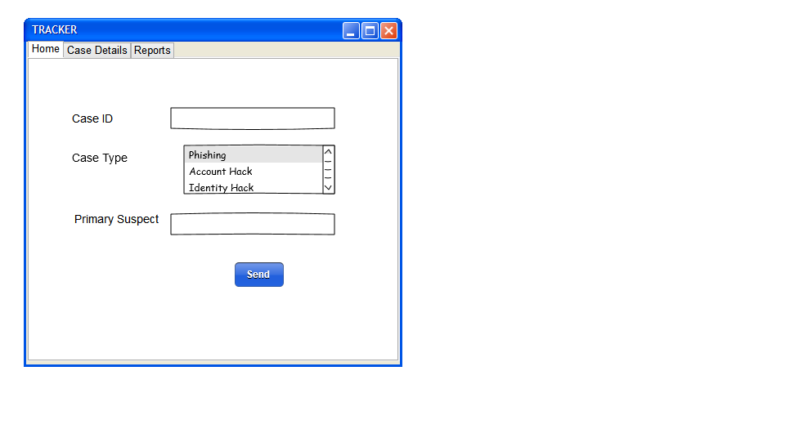

* Tracker Home

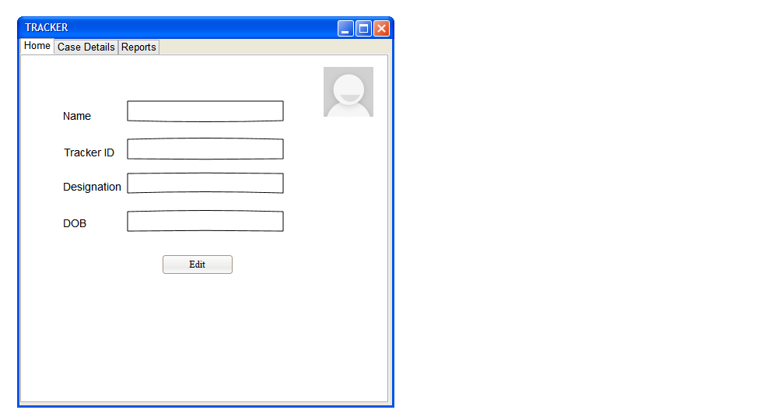

* Tracker Report

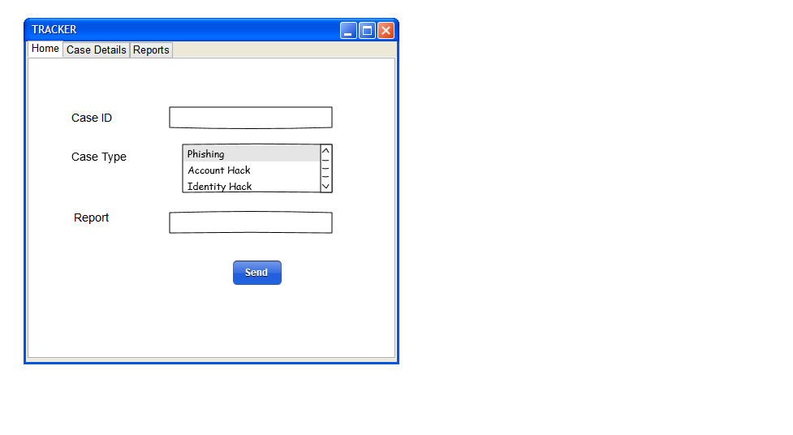

Tracking Supervisor Report

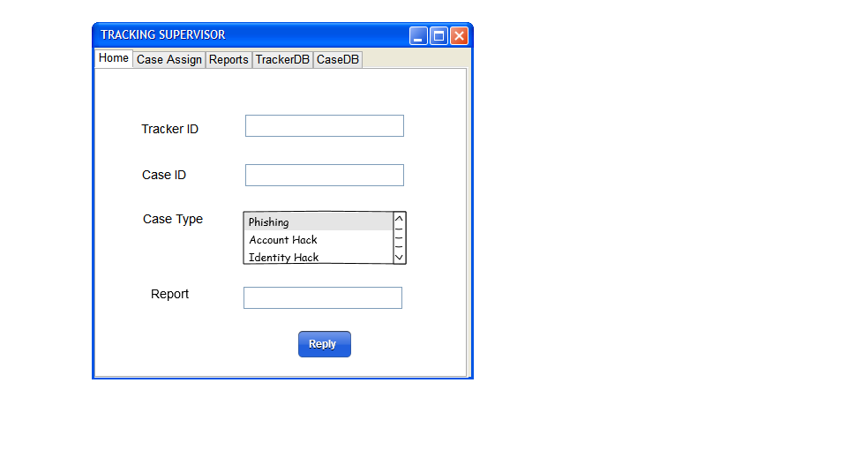

* Tracking Supervisor DataBase

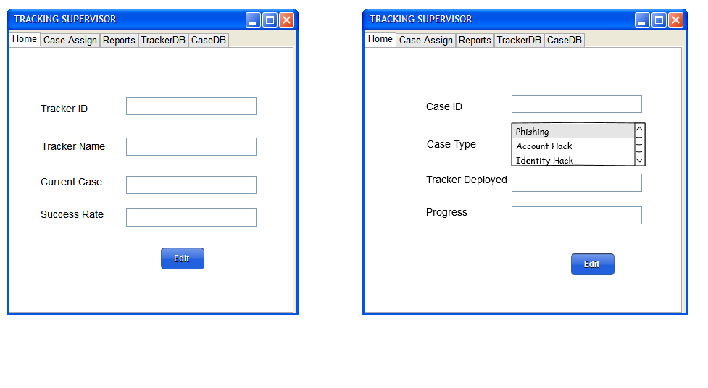

* TS home-

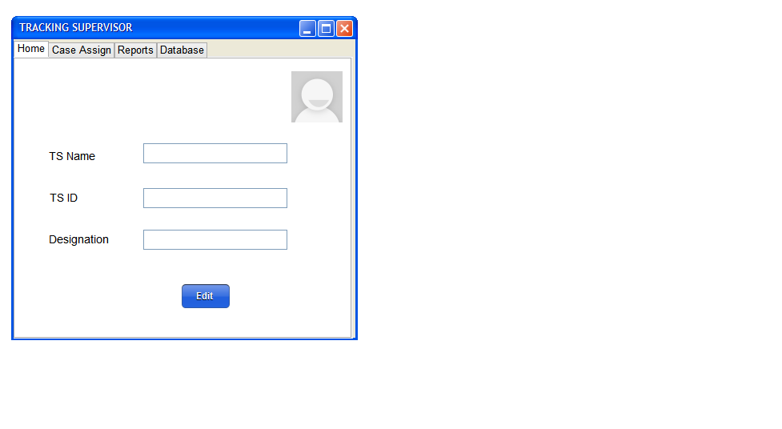

* User page

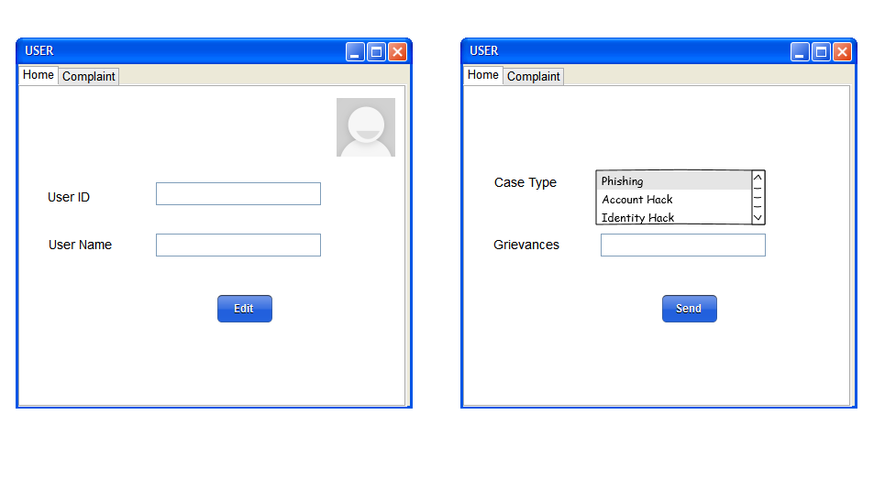

Implemented Modules’ Snapshots

* Login Module

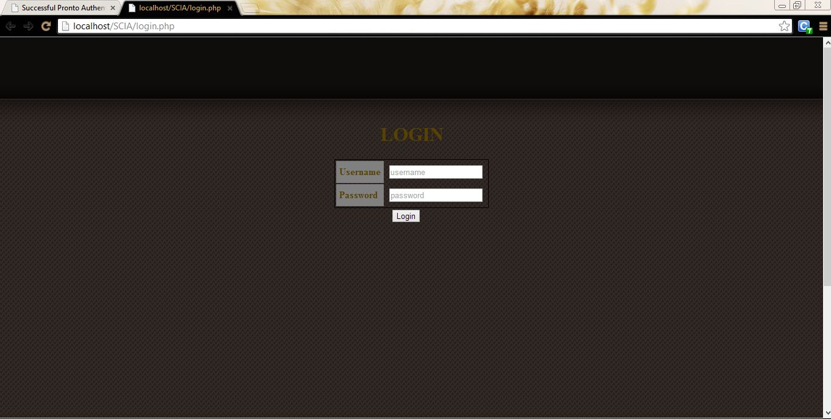

* SCIA Home Page

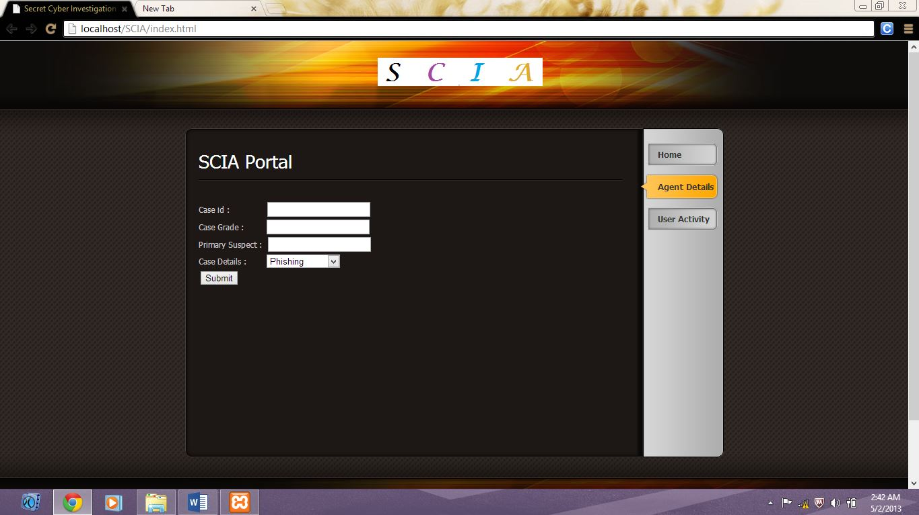

* Tracking agency-assignment details

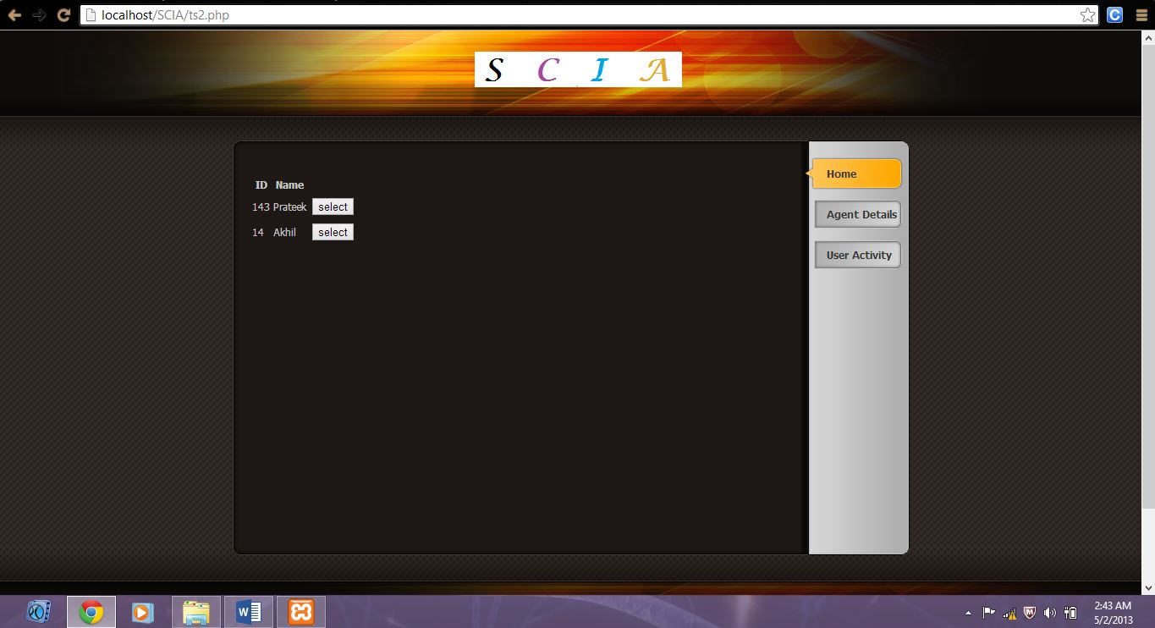

* User reports



Test Cases

|  |  |  |  |  |  |  |
| --- | --- | --- | --- | --- | --- | --- |
| ***Test case ID*** | ***Test Case Details*** | ***Input*** | ***Expected Result*** | ***Actual Result*** | ***Test Outcome*** | ***Solution*** |
| 1 | Login-USERNAME | Try to log in without input to username | Please Enter your User name | Please fill out this field. | Passed | -------- |
| 2 | Login-  PASSWORD | Try to log in without input to password | Please Enter your password | Please fill out this field. | Passed | --------- |
| 3 | Authentication | Username-Swathi_JN  Password-hello123 | Log in | Home Page is shown. | Passed | --------- |
| 4 | 3 Tabs | Try to click and open the | Must open as a field | The same page is shown again. | Failed | Problem with given template, try to modify code. |
| 5 | Case Agent without the same rank | Try to map the case grade with agent rank.  If there is no one | No tracker of the exact grade. | Doesn’t show any tracker. | Passes | --------- |
| 6 | Tracker Login | Try to implement a login for trackers as well. | Have a login so that they can view status. | No login | Failed | Try to implement a module further in the future. |
| 7 | Tracker Employment | Try to add tracker in the database. | New details have been added. | It is only through the Online Server (OS). | Passed | --------- |
| 8 | Complaint Registration | Try to enter complaint as a paragraph with a space for scroll | Has to work for limited characters. | A single line for 200 characters. | Failed | A different PHP form object must be used. |
| 9 | Primary Suspect | Try to give the input without a primary suspect. | It has to take because the citizen (User) may not provide a primary suspect. | Logs in. Doesn’t ask for one. | Passed | ---------- |
| 10 | Username-Password Requirement | Try to click on Username and Password | Must take input normally showing a text box. | Doesn’t let you go to the input field. | Failed | Since, it is for both username and password, Proper Java scripting must be done. |
| 11 | Case Details | While giving input for case details, check the following. | Drop down bar with 3 options must be present. | It is a drop down menu with the 3 cases of –  1)Phishing.  2)Identity theft.  3)Account Hack. | Passed | ----------- |
| 12 | Case assignment | Matching and assigning the test details to the tracker. | It has to be based on a condition that Grade>rank(SRS) | Case grade= Tracker Rank | Failed | To save the work load and time of the trackers and supervisors. |